COPD
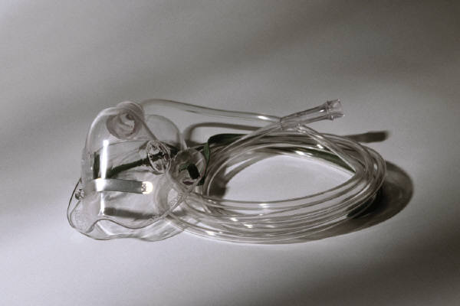
Definition:
Chronic Obstructive Pulmonary Disease is a chronic slowly progressive disorder characterised by airways obstruction which does not change markedly over several months. Click here for more....
COPD is defined according to the percentage of predicted FEV1, e.g. if a patient’s predicted FEV1 is 3.00 litres in one second, but they only can blow 2.00 litres in one second, their percentage predicted peak flow is: 2.00/3.00 x 100 = 66%
COPD is defined as being mild, moderate, or severe:
Mild FEV1 is 60-80% of predicted
Moderate FEV1 is 40-60% of predicted
Severe FEV1 is <40% of predicted.(2)
Symptoms:
Mild:
No abnormal signs
“Smoker’s cough”
Little or no breathlessness
Moderate:
Breathlessness (+/- wheeze) on moderate exertion
Cough (+/- sputum).
Variable abnormal signs – general reduction in breath sounds, presence of wheezes.
Severe:
Breathlessness on any exertion/at rest.
Wheeze and cough often prominent.
Lung overinflation usual; cyanosis, peripheral oedema, and polycythaemia in advanced disease, especially during exacerbations.

Background:
In over 90% of cases of COPD cigarette smoking is the sole cause. It is variously known as CORD, emphysema, chronic bronchitis, obstructive airways disease, chronic airflow limitations, and sometimes chronic asthma.(3) It is on the increase world-wide.
In General Practice the consultation rates relating to COPD per 10 000 patients rise from 417 at age 45-64, to 886 at 65-74, and 1032 at age 75-84. These values are 2-4 times the equivalent rates for angina.
Management:
Generally the management aims for patients with COPD are:
Enable early and accurate diagnosis
Control symptoms
Prevent deterioration
Prevent complications and,
Improve quality of life
Unlike asthma most of the lung function in COPD is fixed. There is however often a degree of reversibility and many patients will have some symptom relief from using bronchodilators.
The place of inhaled steroids remains controversial. Two recent meta-analyses of budesonide and beclomethasone failed to show any benefit in patients with mild to moderate COPD.(4) Controversially the ISOLDE trial (Inhaled Steroids on Obstructive Lung Disease in Europe) showed a small benefit in FEV1 and patient symptom scores using high doses of inhaled fluticasone (2mg daily).(4) Click here for more..... This trial has been criticised for some of it’s methods and also for understating the potential side effects of the treatment.(5) Click here for more.....
The place of oral steroids is also unclear. Prednisolone in a dose of 30 mg daily will improve FEV1 in about 10% of COPD patients but the small benefit is usually off-set by the long-term side effects of treatment.(3) For this reason it is still recommended that steroids are reserved only for patients who are demonstrated to be steroid-responsive by spirometry.(2)
The role of long-acting beta-2 agonists is also unclear. Although evidence is growing of their potential benefits, current guidelines only recommend their use when spirometry has demonstrated improvement.(2) This is confusing advice, as short-acting bronchodilators are recommended if the patient finds them helpful – regardless of whether spirometry demonstrates a therapeutic response.
COPD Guidelines:
These were published in 1997 by the British Thoracic Society.(2) They are surprisingly concise. They cover diagnosis, indications for referral, management of exacerbations and reasons for admission. They recommend:
Make the diagnosis. Use spirometry. If the FEV1 is less than 80% of predicted and there is no or minimal reversibility (<20%) the likely diagnosis is COPD.
Advice and support with regard to smoking cessation as this significantly slows progression of the disease.
Graded treatment according to the severity of the disease.

Mild COPD: short-acting beta-2 agonist or inhaled anticholinergic as required depending on symptomatic response.
Moderate COPD: As for mild disease but regular therapy with either drug or a combination of the two may be needed. Consider steroid trial.
Severe COPD: Combination therapy with regular beta-2 agonist and anticholinergic. Consider addition of other agents. Perform steroid trial. Assess for home nebuliser.
Steroid Trials:
The guidelines recommend 2 weeks of prednisolone 30mg daily, orally. A positive response of >/= 15% justifies steroid treatment (10-20% of patients). Subjective improvement is not a satisfactory end-point.
Referral Criteria:
Suspected severe COPD – to confirm diagnosis/optimise therapy
Onset of Cor Pulmonale – “ “ “ “ “
Assessment for oxygen therapy – to measure blood gases
Assessment in accordance with nebuliser guidelines – to exclude inappropriate prescribing
Assessment for oral steroids – to justify the need for long term treatment or to supervise withdrawal
Bullous lung disease – to identify and assess surgical candidates
<10 pack years smoking – to confirm/exclude diagnosis
Rapid decline in FEV1 – to encourage early intervention
COPD in patients less than 40 years – to identify alpha-1 antitrypsin deficiency, consider therapy and screen family
Uncertain diagnosis – to make diagnosis
Symptoms disproportionate to lung function deficit – to look for other explanations
Frequent infections – to exclude bronchiectasis.
References
- Chronic Obstructive Pulmonary Disease. Robin Taylor. Ed. BMJ 1998;316:1475-80
- British Thoracic Society Guidelines. Thorax 1997;52(suppl) S1-32
- MeReC Bulletin. Vol 9, number 10, 1998
- Randomised, double blind, placebo controlled study of fluticasone proprionate in patients with moderate to severe chronic obstructive pulmonary disease: the ISOLDE trial. Burge et al. BMJ 2000;320:1297-1303 (13 May)
- Side effects are source of concern. Lipworth et al. Letter. BMJ 2000. 321;(7272) 1349
This tutorial has been prepared by Dr P Harrop, Riversdale Surgery, Wednesday, 30 October 2002

